**The Sydney Opera House, Australia**

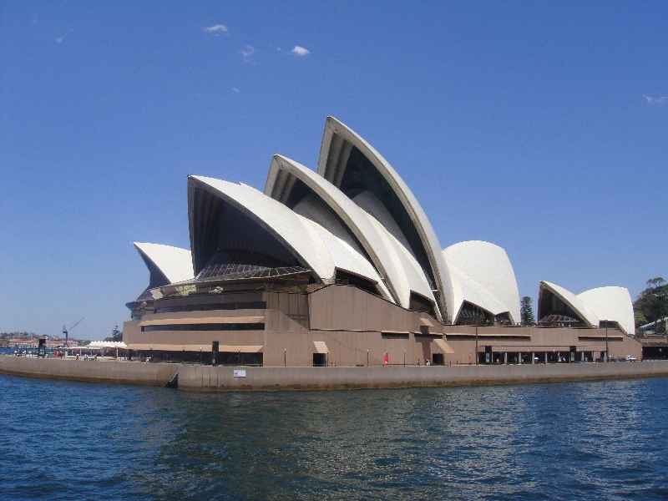

Sydney Opera House is a performing arts centre in Sydney, Australia. It was built by a Danish architect Jorn Utzon for which he was awarded Pritzker Prize (highest architectural honour) in 2003 stating The Opera House as a “Masterpiece”. The Sydney Opera House was made a UNESCO World Heritage Site in 2007.